Genius Hour
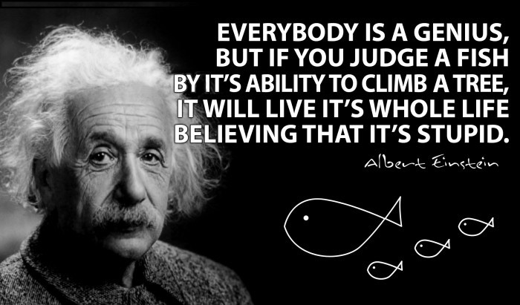
Students will have an entire class period to study someone or something from the unit that they are interested in. Then they will create a unique way to present their knowledge on the person or thing they chose to study. Students must use all of the class period studying and/or working on this project. Any work done outside of class must be a supplement to the work done in class. For example: students can’t do it all at home then sit in class and do nothing. Also, any extra supplies a student feels is necessary for the project must be brought to class. If the desired supplies are not in class on this day then another project will be assigned by the teacher.
Below is a list of many possible ideas that students can use for their genius hour project. Any ideas not on this list must be approved by the teacher.
- Create a poster
- Make a PowerPoint presentation
- Design a model
- Make a shoebox diorama
- Use a 3-panel display board
- Make a timeline
- Create a board game incorporating key elements.
- Write a poem
- Write and perform a skit
- Make a TV or radio commercial
- Make a collage
- Create a test about the topic
- Make a word search
- Make a crossword puzzle
- Write a report
- Create a flow chart or diagram
- Write an interview of a relevant person
- Create questions and an answer key
- Write journal/diary entries
- Write a postcard or letter exchange
- Create a scrapbook
- Create a photo album
- Make an instructional video
- Give a presentation
- Create an interactive notebook
- Create a set of task cards
- Make a pamphlet or brochure
- Write a newspaper article
- Perform a puppet show
- Have a panel discussion of “experts”
- Compose a rap or other song
- Use a Venn diagram to compare two aspects of the topic
- Design a comic strip about the topic
- Create a children’s story about the topic
- Create a map
- Write a fable or myth about the topic
- Create a help wanted add and a letter/resume to answer it
- Write a text message dialogue relevant to the topic
- Write a series of tweets relevant to the topic
- Create a Facebook wall relative to the topic
- Create a Pinterest board relative to the topic
- Start a blog
- Decorate a box and fill with relevant objects
- Create a foldable
- Create a flip book
- Create a cereal based on the topic (cover a cereal box)
- Assemble a time capsule
- Create several bookmarks about different aspects of the topic
- Write a recipe relevant to the topic (good for showing causes of an event)
- Do a newscast
- Write an acrostic poem
- Create an Internet scavenger hunt
- Write an advice column with several problems related to the topic
- Create flash cards or trivia cards
- Create a cheer relevant to the topic
- Make a short documentary film
- Create a museum exhibit
- Create a top 10 list relevant to the topic
- Create a video game
- Make a “Choose Your Own Adventure”
- Create a mini book with one fact/idea per page
- Create a glossary of relevant terms
- Make a paper chain with a different fact for each link
- Make a flower with a different fact for each petal
- Write a handbook or instruction book
- Create a newsletter

